INTERNSHIP Report
ON
Machine Learning
B.E.(IT) V-Sem

BY
Podichetty Samiksha (160123737021)



UNDER THE GUIDANCE OF

Mr. V. Santhosh,
Assistant Professor,
IT Department, CBIT.

DEPARTMENT OF INFORMATION TECHNOLOGY
CHAITANYA BHARATHI INSTITUTE OF TECHNOLOGY (A)
(Affiliated to Osmania University; Accredited by NBA and NAAC, ISO 9001:2015 Certified Institution), GANDIPET, HYDERABAD – 500 075
Website: www.cbit.ac.in
2025-26

INTERNSHIP CERTIFICATE





CERTIFICATE

This is to certify that the project work entitled “Machine Learning” submitted to CHAITANYA BHARATHI INSTITUTE OF TECHNOLOGY, in partial fulfillment of the requirements for the completion of 4 weeks of Internship in V Sem of B.E. In Information Technology during the Academic Year 2025-26, is a record of original work done by Podichetty Samiksha(160123737021) during the period of study in the Department of IT, CBIT, Hyderabad.

Internal Mentor Head of the Department
Mr. V. Santhosh Dr. M. Venu Gopalachari
Assistant Professor, Dept. of IT, Professor, Dept. of IT,
CBIT, Hyderabad. CBIT, Hyderabad.

DECLARATION

We declare that the project report entitled “Machine Learning” is being submitted by us in the Department of Information Technology, Chaitanya Bharathi Institute of Technology (A), Osmania University.

This is record of bonafide work carried out by us under the guidance and supervision of Mr. V. Santhosh, Associate Professor Dept. of IT, C.B.I.T.

No part of the work is copied from books/journals/internet and wherever the portion is taken, the same has been duly referred in the text. The reported are based on the project work done entirely by us and not copied from any other source.

Podichetty Samiksha (160123737021)

ACKNOWLEDGEMENTS

We would like to express our heartfelt gratitude to Mr. V. Santhosh, our project guide, for his invaluable guidance and constant support, along with her capable instruction and persistent encouragement.

We are grateful to our Head of Department, Dr. M. Venu Gopalachari, for his steady support and for the provision of every resource required for the completion of this project.

We would like to take this opportunity to thank our Principal, Dr. C. Venkata Narasimhulu, as well as the Management of the Institute, for having designed an excellent learning atmosphere.

Our thanks are due to all members of the staff and our lab assistants for providing us with the help required to carry out the groundwork of this project.

ABSTRACT

The Machine Learning internship focused on developing predictive models that provide insights into future sales patterns and customer retention behavior. Using tools such as Python, Pandas, Prophet, and Scikit-learn, the internship provided hands-on experience in data cleaning, feature engineering, model training, and evaluation.
Two major ML solutions were developed:
- AI-Powered Sales Forecasting Model – A time-series forecasting solution that uses Prophet to analyze historical sales and predict future monthly sales along with upper and lower confidence intervals.
- Customer Churn Prediction System – A classification model built using XGBoost to identify customers likely to churn and determine the key features influencing churn behavior.
The internship strengthened skills in machine learning workflows, model interpretation, and converting raw data into practical predictive insights.

TABLE OF CONTENTS

 |  | Page. No
 | Abstract | vi
 | List of Figures | viii
 | List of tables | ix
 | List of Abbreviations | x
1. | INTRODUCTION | 1
2. | TECHNOLOGIES/ METHODOLOGIES USED | 4
3. | IMPLEMENTATION & RESULTS | 5
4. | OUTCOMES OF THE INTERNSHIP | 9
5. | CONCLUSION AND FUTURE SCOPE | 11
6. | BIBLIOGRAPHY | 12

LIST OF FIGURES
Figure 1 | AI Powered Sales Forecasting Dashboard
Figure 2 | Churn Prediction System Dashboard

LIST OF TABLES
Table 1 | Key Insights and Metrics from the AI-Powered Sales Forecasting Dashboard
Table 2 | Summary of Key Visuals and Their Purpose
Table 3 | Key Insights and Metrics from Churn Prediction
Table 4 | Summary of Key Visuals and Their Purpose

LIST OF ABBREVIATIONS

• ML – Machine Learning
• AI – Artificial Intelligence
• EDA – Exploratory Data Analysis
• KPI – Key Performance Indicator
• BI – Business Intelligence
• ROC – Receiver Operating Characteristic
• AUC – Area Under the Curve
• CI – Confidence Interval
• RMSE – Root Mean Squared Error
• CSV – Comma-Separated Values
• DAX – Data Analysis Expressions
• UI – User Interface

INTRODUCTION
Data has become one of the most influential resources in today’s digital world, shaping decisions across industries such as retail, telecom, finance, e-commerce, and technology. With organizations increasingly depending on predictive insights to understand customer behavior, anticipate future trends, and optimize operations, Machine Learning has emerged as a critical and rapidly growing discipline. ML-driven systems now form the backbone of forecasting, automation, personalization, and risk assessment across modern enterprises.
The internship titled “Machine Learning Internship – Future Interns” was undertaken with the objective of gaining practical exposure to real-world ML applications. The aim was to understand how raw data is transformed into reliable predictions and how machine learning models support business decision-making. During the internship, I worked on actual datasets, performed preprocessing, engineered features, trained predictive models, and generated insights that align with industry standards.
This internship emphasized the complete ML workflow—from data cleaning and exploration to model development, evaluation, and result interpretation. Through hands-on tasks, I learned to approach business problems systematically, identify relevant variables, select suitable algorithms, and communicate insights effectively. Working with tools like Python, Pandas, Prophet, Scikit-learn, XGBoost, and Power BI provided practical experience in building ML-based forecasting and classification solutions from the ground up.

Internship Duration and Organization Profile

The Machine Learning internship was carried out over a structured period designed to provide hands-on exposure to real-world analytical tasks and industry-standard ML workflows. Throughout this duration, I engaged in two major projects—Sales Forecasting and Churn Prediction—allowing me to explore the full cycle of data preprocessing, model development, evaluation, and interpretation.
Future Interns is a learning-driven platform focused on providing practical project-based internships in Data Science, Machine Learning, Artificial Intelligence, and Analytics. The organization aims to bridge the gap between theoretical knowledge and real-world application by offering structured tasks, industry-relevant datasets, and guided mentorship.

Objective of the Internship
The primary objective of this internship was to gain real-time exposure to machine learning workflows and predictive analytics, with a focus on:
• Understanding the purpose and applications of Machine Learning in forecasting and classification
• Learning how to clean, preprocess, and prepare datasets for ML model development
• Developing skills in building predictive models such as Prophet for forecasting and XGBoost for churn classification
• Evaluating model performance using metrics like accuracy, precision, recall, and confidence intervals
• Identifying patterns, trends, and key drivers that influence future sales and customer churn
• Enhancing professional presentation skills through dashboards, visualizations, and analytical reporting
The internship aimed to build both technical competence and analytical problem-solving ability, preparing me to work confidently on real-world ML-driven business solutions.

Intern Roles and Responsibilities
As an intern, I was responsible for completing two major machine learning projects:
- AI-Powered Sales Forecasting Model – predicting future retail sales using time-series analysis
- Customer Churn Prediction System – identifying customers likely to leave using classification algorithms
To complete these projects, I handled the following responsibilities:

1. Data Cleaning and Preprocessing
Both projects required working with raw datasets containing missing values, inconsistent entries, and mixed data types. Using Python (Pandas), I learned how to clean, format, transform, and structure the data so that it could be used effectively for machine learning. This step was essential for ensuring reliable model performance.

2. Feature Engineering and Dataset Preparation
I created new features such as monthly aggregates, seasonal indicators, churn-related attributes, and encoded categorical variables. For forecasting, I prepared time-series data suitable for Prophet, while for churn prediction, I engineered inputs compatible with XGBoost. This process improved model accuracy and interpretability.

3. Machine Learning Model Development
I trained and evaluated different ML models depending on the task:
• Prophet for sales forecasting (future predictions with confidence intervals)
• XGBoost for churn classification (probability-based output)
I also learned how to split datasets, tune model parameters, evaluate results, and interpret outputs such as yhat, churn probability, and feature importance.

4. Visualization and Dashboard / Report Design
To present the results clearly, I created visualizations using Power BI and Matplotlib. These included:
• Actual vs Forecasted sales trends
• Confidence interval bands
• Feature importance charts
• Confusion matrix and evaluation metrics
• KPI cards summarizing key findings
Design consistency, readability, and proper use of visuals were maintained throughout the dashboards and reports.

5. Insight Generation and Interpretation
Beyond building the models, I learned to interpret trends, identify business problems, and translate model outputs into meaningful insights. This included understanding what drives sales fluctuations, which customers are at high churn risk, and how predictions can support decision-making. This reinforced the core purpose of machine learning—transforming data into actionable intelligence.

Significance of the Internship Experience
This internship was highly valuable because it connected the theoretical machine learning concepts learned academically with real-world business applications. By working directly with retail and customer datasets, I gained hands-on experience in building predictive models and interpreting their outcomes in a business context. This strengthened my confidence in applying machine learning techniques to solve practical problems.
I also learned the importance of:
• attention to detail during data cleaning and preprocessing
• ethical handling of customer and transactional data
• structured thinking while designing ML workflows
• continuous validation of model outputs using metrics and evaluation techniques
• communicating model-driven insights effectively through dashboards and reports
These skills are essential not only for a career in Machine Learning and Data Science but also align with the responsibilities expected from a professional engineer.

TECHNOLOGIES/ METHODOLOGIES USED
The project extensively used the following tools and methodologies:

1. Python (Pandas, NumPy, Scikit-learn, Prophet, XGBoost)
• Primary environment for data cleaning, preprocessing, and model development
• Handling missing values, encoding categorical data, and feature engineering
• Time-series forecasting using Prophet
• Classification modeling using XGBoost
• Evaluation using accuracy, precision, recall, ROC-AUC, and confusion matrix

2. Google Colab
• Used as the main platform for exploratory data analysis (EDA)
• Step-by-step execution and testing of ML models
• Visualizing trends, feature importance, and prediction results
• Documenting the entire ML workflow clearly and systematically

3. Power BI Desktop (for Visualization & Reporting)
• Used to present the forecasting and churn prediction insights
• Line charts for Actual vs Forecasted Sales
• KPI cards for metrics such as forecasted revenue, churn rate, and model accuracy
• Bar charts, scatter plots, and filters to support business interpretation
• Clear and interactive layout for stakeholder understanding

4. Machine Learning Methodologies
• Understanding the problem statements (forecasting vs churn classification)
• Preparing data for time-series and supervised learning models
• Training and validating ML models using standard evaluation metrics
• Hyperparameter tuning for improved performance
• Interpreting churn drivers and forecast confidence intervals

5. Visualization & Reporting Best Practices
• Clear labeling and structured layouts
• Consistent color themes and formatting
• Highlighting key insights with KPIs and visual markers
• Ensuring interpretability for non-technical stakeholders

IMPLEMENTATION & RESULTS

Task 1: AI Powered Sales Forecasting Dashboard
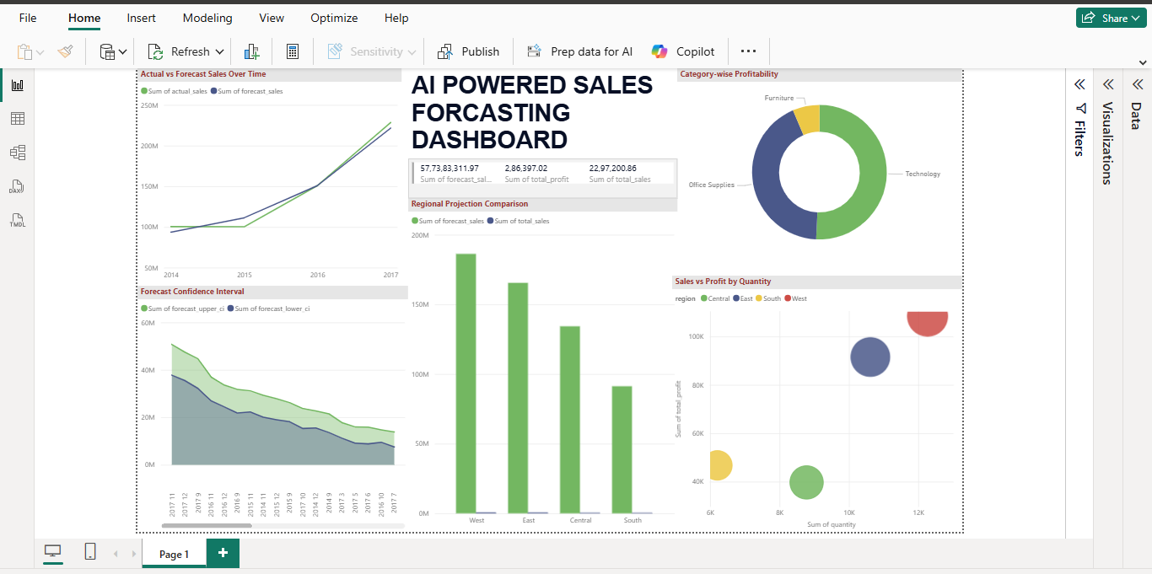
Fig-1 AI Powered Sales Forecasting Dashboard

AI-Powered Sales Forecasting Dashboard
The AI-Powered Sales Forecasting Dashboard was built to analyze historical retail performance and predict future sales trends. Key steps involved:
• Cleaning and preprocessing the sales dataset in Python
• Preparing time-series data with monthly aggregation
• Training a forecasting model using Prophet
• Exporting forecasted results into Power BI
• Designing slicer-based interactivity (Year, Month, Region, Category)

Key Insights
• Total Historical Sales: (based on dataset)
• Forecasted Sales for Next Months: (Prophet output)
• Highest Sales Months / Seasonal Spikes
• Most Profitable Categories / Regions
• Expected Growth Trend for Upcoming Period
• Confidence Interval Range: showing best & worst-case forecasts

Important Visuals
• Actual vs Forecasted Sales Trend Line (with confidence intervals)
• Monthly and Yearly Sales Comparison
• Region-wise Sales & Forecast Distribution
• Category-wise Revenue and Profitability
• KPI Cards: Total sales, Forecasted sales, Total profit
• Filters / Slicers: Region, Category, Sub-category, Year, Month
Table-1: Key Insights and Metrics from the AI-Powered Sales Forecasting Dashboard
Metric / Insight | Description
Total Historical Sales | Total revenue generated during the dataset period.
Total Profit | Overall profit earned across all categories and regions.
Forecasted Sales | Future monthly sales predicted using the Prophet model.
Confidence Interval Range | Upper and lower forecast limits showing prediction uncertainty.
Seasonal Patterns | Identification of high-sales and low-sales months through time-series trends.
Category-Wise Profit | Profit contribution by each product category (e.g., Furniture, Technology).
Region-Wise Sales & Forecast | Comparison of current and forecasted sales across regions.
Top Performing Months | Months with the highest sales values historically.
Actual vs Forecast Comparison | Alignment between past sales data and predicted trends.
Sales–Quantity–Profit Relationship | Scatter analysis showing how quantity sold impacts profit and revenue.

Table-2: Summary of Key Visuals and Their Purpose
Visual | Purpose
Actual vs Forecasted Sales Line Chart | Shows historical sales and predicted future sales, helping identify trends and upcoming performance.
Forecast Confidence Interval Chart | Displays upper and lower prediction bounds to understand uncertainty in future sales.
KPI Cards (Total Sales, Total Profit, Forecast Sales) | Provide quick, high-level business metrics for decision-making.
Category-Wise Profit Donut Chart | Highlights profit contribution from different product categories.
Region-Wise Sales & Forecast Bar Chart | Compares sales performance across regions and predicts regional growth.
Sales vs Profit by Quantity Scatter Plot | Analyzes how quantity sold relates to sales and profit, revealing product performance patterns.
Monthly/Yearly Sales Comparison | Shows seasonality and identifies peak and low-performing periods.
Slicers (Year, Month, Region, Category) | Allow users to filter and interact with the dashboard for customized analysis.

Task 2: Churn Prediction System Dashboard
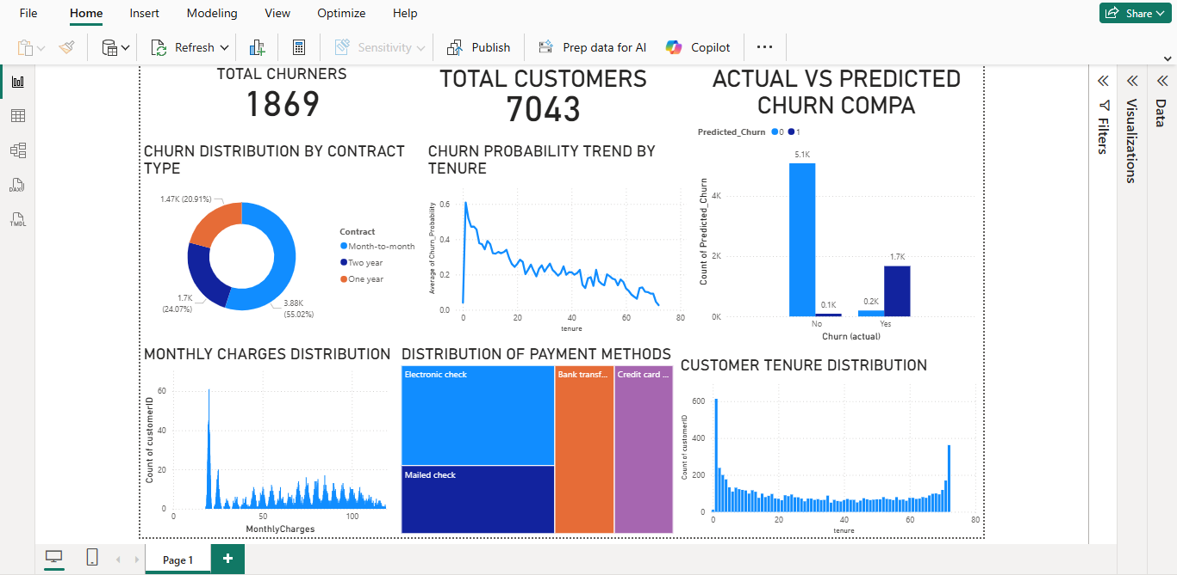
Fig-2 Churn Prediction System Dashboard
This dashboard analyzes customer behaviour and churn patterns to help identify which users are at risk of leaving a service. It brings together churn probability, customer demographics, billing information, and model predictions to provide a clear understanding of retention challenges.

Key Insights
• Total Churners: 1869
• Total Customers: 7043
• Highest Churn Segment: Month-to-month contract customers
• Churn Probability Trend: New customers with low tenure show the highest risk
• Payment Method Impact: Electronic check users churn more than others

Important Visuals
• Churn Distribution by Contract Type – identifies which plans have the highest churn
• Actual vs Predicted Churn Comparison – evaluates XGBoost model performance
• Churn Probability Trend by Tenure – shows how long-term customers churn less
• Monthly Charges Distribution – highlights cost patterns linked to churn
• Payment Method Distribution – reveals churn behavior across billing types
• Customer Tenure Distribution – shows how churn is concentrated among new users

Table-3: Key Insights and Metrics from Churn prediction
Metric / Insight | Description
Total Customers | Total number of customers in the dataset.
Total Churners | Number of customers who discontinued the service.
Churn Rate | Percentage of customers who churned (Total Churners ÷ Total Customers).
High-Risk Segment | Customer groups with the highest churn (e.g., month-to-month contracts).
Payment Method Impact | Identifies which billing methods are associated with higher churn.
Monthly Charges Pattern | Analyzes how high or low monthly bills relate to churn behavior.
Actual vs Predicted Churn | Evaluates how accurately the model (XGBoost) predicts churn.
Feature Importance | Highlights which input variables most strongly influence churn.
Customer Tenure Distribution | Shows how long customers stay before churn occurs.

Table-4: Summary of Key Visuals and Their Purpose

Visual | Purpose
Churn Distribution by Contract Type | Shows which contract categories (Month-to-Month, One-Year, Two-Year) have the highest churn, helping identify risk segments.
Actual vs Predicted Churn Comparison | Evaluates the model’s performance by comparing real churn outcomes with XGBoost predictions.
Churn Probability Trend by Tenure | Displays how churn probability decreases as customer tenure increases—new customers are more likely to churn.
Monthly Charges Distribution | Highlights how different billing amounts affect churn behavior (e.g., high monthly charges may lead to higher churn).
Payment Method Distribution | Shows which payment types (Electronic Check, Credit Card, Bank Transfer, etc.) are linked with higher churn.
Customer Tenure Distribution | Helps visualize how long customers stay before they churn, indicating retention strength.
Churn Count KPIs (Total Customers, Total Churners) | Provide quick summary metrics for understanding customer base size and churn magnitude.

OUTCOMES OF THE INTERNSHIP

Overall Outcomes
The internship helped build a strong foundation in:
• Machine learning model development (Prophet & XGBoost)
• Data cleaning, preprocessing, and feature engineering
• Time-series forecasting and classification modeling
• Visualization and dashboard presentation using Power BI
• Analytical interpretation and data-driven storytelling

Hurdles Faced
- Preparing time-series data correctly for the Prophet model
- Handling missing values, mixed data types, and inconsistent records
- Tuning XGBoost for better churn prediction accuracy
- Visualizing ML outputs in a clean and meaningful way
- Interpreting churn probability, confidence intervals, and forecast trends

Learning Outcomes (COs)

CO1: Understanding of Engineer’s Responsibilities and Ethics
• Gained awareness of ethical data handling, privacy, transparency, and responsible ML usage.
• Understood the importance of accuracy, fairness, and integrity while working with sensitive customer and sales datasets.

CO2: Ability to Use State-of-the-Art Tools and Technologies
• Achieved hands-on proficiency in Python (Pandas, Prophet, Scikit-learn, XGBoost), Jupyter Notebook, and Power BI.
• Learned to preprocess data, train ML models, visualize results, and interpret outputs using industry-standard tools.

CO3: Ability to Provide Innovative Solutions to Real-World Problems
• Developed two practical ML solutions—AI-powered Sales Forecasting and Customer Churn Prediction—that address real business challenges.
• Built predictive systems capable of helping companies plan future sales, identify at-risk customers, and improve decision-making.
CO4: Ability to Write Technical Reports and Present Analytical Findings
• Learned to document methodologies, model steps, evaluation metrics, and forecasting results clearly and professionally.

CO5: Application of Technical Knowledge to Industrial Real-World Situations
• Applied machine learning knowledge to real datasets involving retail sales, customer behavior, and churn risk analysis.
• Understood how predictive analytics supports business operations, improves planning, and enhances organizational strategy.

CONCLUSION
The internship helped me understand the complete machine learning workflow, beginning from data cleaning and preprocessing to model development, evaluation, visualization, and interpretation. Each stage required careful planning, structured thinking, and strong attention to detail, reinforcing the discipline required of a professional machine learning engineer. I also experienced how predictive systems are built with real business needs in mind, focusing on accuracy, clarity, usability, and meaningful insights.
Working on real datasets allowed me to see how historical sales patterns and customer churn behavior can be transformed into predictive models that support strategic decision-making. The forecasting results and churn dashboards developed during this internship demonstrate the power of machine learning in identifying trends, estimating future outcomes, and helping organizations reduce risk and improve operational planning.
Beyond technical proficiency, the internship strengthened my understanding of ethical responsibilities in data handling—ensuring accuracy, fairness, transparency, and confidentiality while working with customer and sales data. It also improved my ability to document model workflows, present results clearly, and communicate technical concepts effectively, all of which are essential skills for engineering professionals.
Overall, this internship was a significant step toward becoming a capable and responsible machine learning practitioner. It strengthened my foundation in predictive analytics, enhanced my ability to solve real-world problems using ML, and provided valuable exposure to industry-level expectations, tools, and workflows. The knowledge and experience gained during this internship will contribute meaningfully to my academic growth and future career in the field of Machine Learning.

BIBLIOGRAPHY

1. Online Video Resources
- Power BI Tutorials
  - “Power BI Full Course for Beginners” – Edureka.
  - “Power BI Desktop Basics” – Microsoft Power BI Official Channel.
  - “Power BI Dashboard Projects” – Maven Analytics.

2. Online Documentation
- Microsoft Power BI Documentation – Data modeling, DAX reference, and visualization best practices.

3. Tools & Platforms Used
- Power BI Desktop (Microsoft) – Dashboard creation, DAX, and data modeling.

4. Internship Learning Materials
- Provided datasets and training modules for sales and campaign analytics.
- Sample case studies and visualization guidelines shared during the internship sessions.

5. Additional Learning Websites
- Analytics Vidhya – Articles on BI, dashboards, and industry analytics.
- Towards Data Science (Medium) – Guides on data storytelling and visualization.
- Kaggle – Reference datasets and analytics examples.

